Plastics Sales Online

Functional Specifications
Version 1

Prepared by
Last Signal

Contents
DOCUMENT HISTORY 3
PURPOSE 4
SCOPE 4
ASSUMPTIONS 4
OUT OF SCOPE 4
DECISIONS 4
DELIVERABLES 4
APPLICATION 4
1.1 Application Roles 4
1.1.1 Plastics Users 4
1.1.2 Supplier Users 5
1.1.3 Business Admin Users 5
1.1.4 Support Users 5
1.1.5 System Admin Users 5
1.2 Website Layout and Design 5
1.2.1 Login page 5
1.2.2 Registration 6
1.2.3 Home Page 6
1.2.4 Creating Requisition While not logged in 8
1.3 Reports 9
1.4 Glossary 9

DOCUMENT HISTORY

Version | Creation/Revision  Date | Created/Updated by | Comments
1.0 | Jan 17, 2011 | Bahram Daneshgar | Document Creation
1.1 | Jan 23, 2011 | Bahram Daneshgar | Added Product Manager Mockups
1.2 | Jan 25, 2011 | Serjik Dikaleh | Corrections
1.3 | Jan 25, 2011 | Bahram Daneshgar | Applied Serjik’s corrections and answered the review questions

PURPOSE
The purpose of this document is to define a system that can be placed between plastics suppliers (manufacturing or reseller) and consumers. The Project will help consumers to get quote from different suppliers for the same product. Once a consumer submits a requisition, the system will request a quote from the registered suppliers simultaneously and report all of them back to the consumer.

SCOPE
Anything not identified in this document and project plan is out of scope. Out of scope items can be included in the project by submitting a signed and approved change order outlining details of the change requested along with any impact to original schedule and/or costs.

ASSUMPTIONS
TO BE IDENTIFIED

OUT OF SCOPE
TO BE IDENTIFIED

DECISIONS
TO BE IDENTIFIED

DELIVERABLES
TO BE IDENTIFIED

APPLICATION

Application Roles

Plastics Consumer
Plastics Consumers are the major users of the application. They are either the end users or the resellers (distributors). They should be able to do the following even before logging in:
- To define a custom product
- To add a custom product to the requisition (shopping cart)
They should be able to do the following once they are logged in:
- To save a custom product with a specific name (part number) for the future use; the name will be unique at the user level.
- To submit a requisition to a specific list of Plastics Suppliers; the list is limited to the registered suppliers in the application and plastics users are able to choose to select between them.
- To place an order by changing a quote to a purchase order

Supplier
This group of users provides the plastics goods. They should be able to do the following:
- Fulfill and price the requisitions and change them to quotes and submit them to the plastics consumers
- Receive purchase orders to be fulfilled (manufacture/acquire, receive payment and ship)

Business Administrator
This group of users has the highest authority in terms of business administration. They have access to the accounts of the suppliers and consumers. They can also generate and view business reports.

Support Users
The Support Users are the users are located in a call center and answer the phone calls or reply to fax and email communication from consumers and suppliers. They are able to create/modify accounts, logs customer calls and escalate issues to the business administrators. They are also able to reset passwords.

System Administrators
This group of users is the technical users. They have the ability to assign roles, configure system parameters and get the administration reports.

Website Layout and Design

Login page
Login page includes the regular user id and password fields. The same login page is used for different application users.
Login page has a link to reset the password (forgotten password)
There are two different registration links on the login page: registration for suppliers and consumers. See Registration
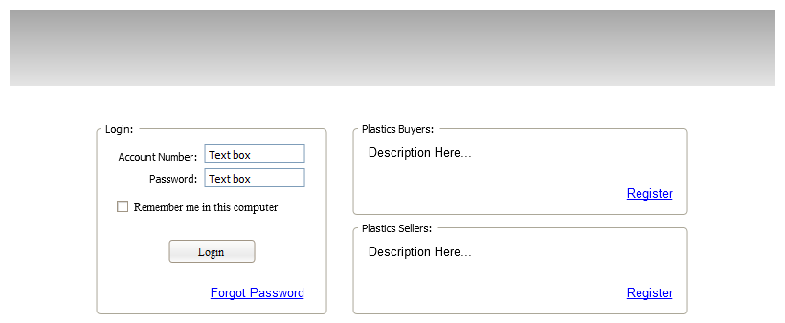

Registration
Consumers can register themselves using the Plastics Consumer Registration page. They are also able to ask support to register them over the phone. Suppliers can only be registered by Business Administrators.
Business Administrators are created by system administrators. (This can be done in the database level and no page is required)
Creating system administrators also can be done in the database level and no page is required.

Home Page
Home page will be different based on the role of authenticated users.

Anonymous Users’ Home Page
Users are able to perform certain activities before logging in. Most of these activities relate to finding information. However, there is an important activity that they should be able to perform, which is the ability to create a quote. Additionally they should be able to make custom products and add them to the quote.

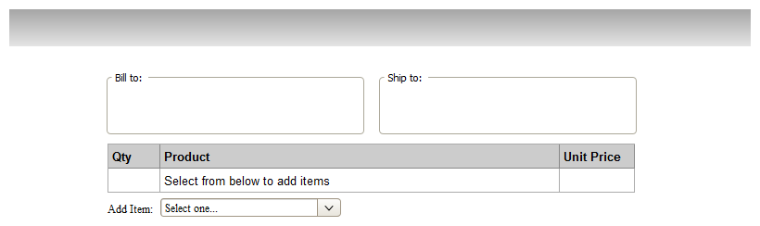
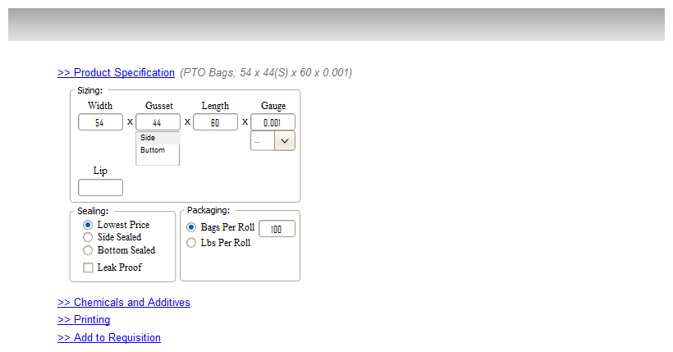
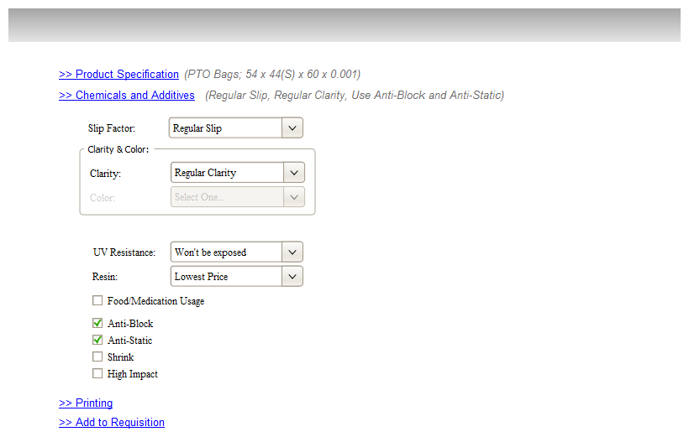
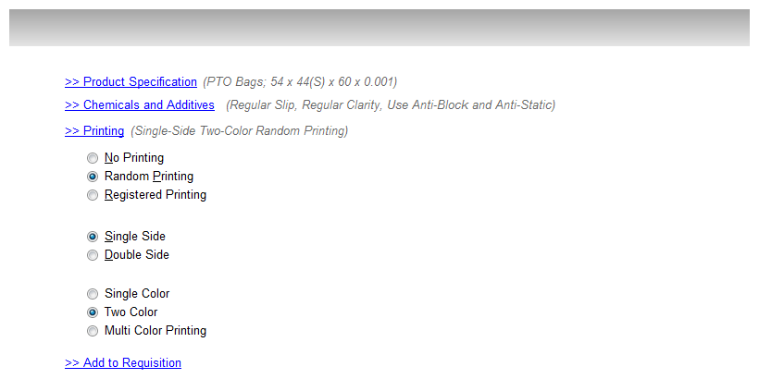
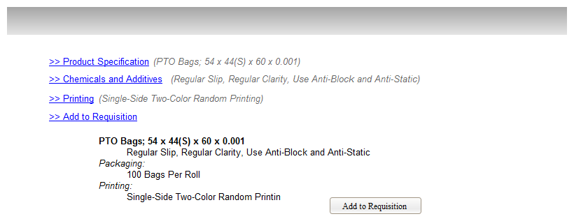

Plastics Users Home Page

Suppliers Users Home Page

Business Admin Users Home Page

System Admin Users Home Page

Creating Requisition While not logged in
Anonymous users should have the ability to create custom products and create a requisition. The system will save the requisition on the server side with a temporary unique id and keep the same id within the client cookie.
The system will remove temporary products, items and requisitions using the application garbage collector.

Reports

Glossary
Requisition
A request for a quote that is submitted by the plastics users
Quote
Order
In this document Order are the same as Purchase Orders
PO
See Purchase Order
Purchase Order
Approved quote by the plastics users. This is the contract document between the end user and the supplier in regards to the purchase.
System Admin User
Business Admin User
Supplier User
Suppliers can be plastic manufacturers or plastics distributors.
Plastics User
End user of the plastics which are the most popular users in the application

Product Maker Module
- Used to make a custom product. Users should be able to make a custom product using this module whether they are logged in or not.
- The input and output of this module will be a standard definition of the product and its measures.
- The System should be able to save the product to the database, save it to cookie or export it to XML or text.
Requisition
- A requisition is a draft document created by a user in order to get a quote from the suppliers.
- Users make a requisition and send it to a selected list of suppliers selected from a list of available ones in the system
- Only logged in users should be able to submit a Requisition
- Once a user submits a requisition, it will be sent to those suppliers that have been selected by user.

